**PROCESS SYNCHRONIZATION AND SCHEDULING**

**LAB # 08**



**Spring 2021**

**CSE204L Operating System**

Submitted by: **Ashfaq Ahmad**

Registration No: **19PWCSE1795**

Class Section: **B**

“On my honor, as student of University of Engineering and Technology, I have neither given nor received unauthorized assistance on this academic work.”

Student Signature: ______________

Submitted to:

**Engr. Mian Ibad Ali Shah**

August 24, 2021

**Department of Computer Systems Engineering**

**University of Engineering and Technology, Peshawar**

**Lab Objective(s):**

* Solve the Critical Section Problem
* Implement different Process Scheduling Algorithms.

**Task # 01:**

Solve the critical section problem using:

1. Peterson solution
2. Test and set instruction
3. producer/consumer problem

**Peterson Solution:**

**Code:**

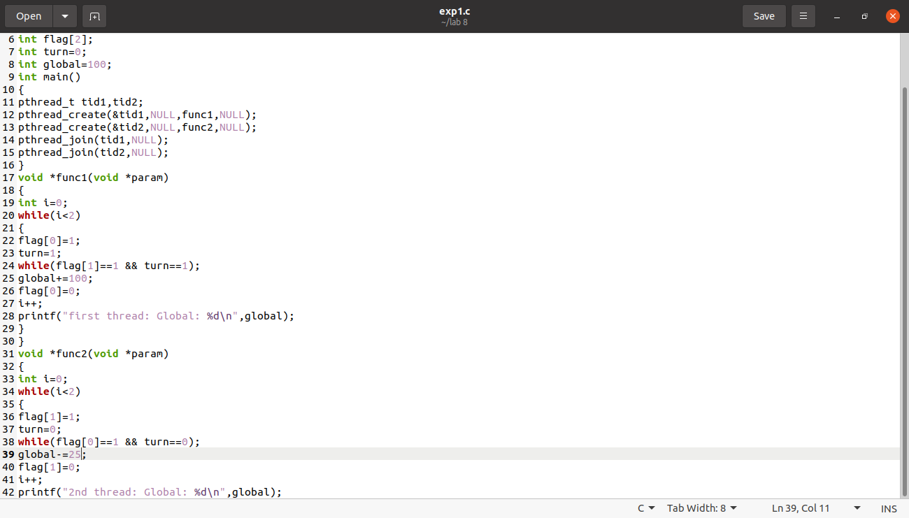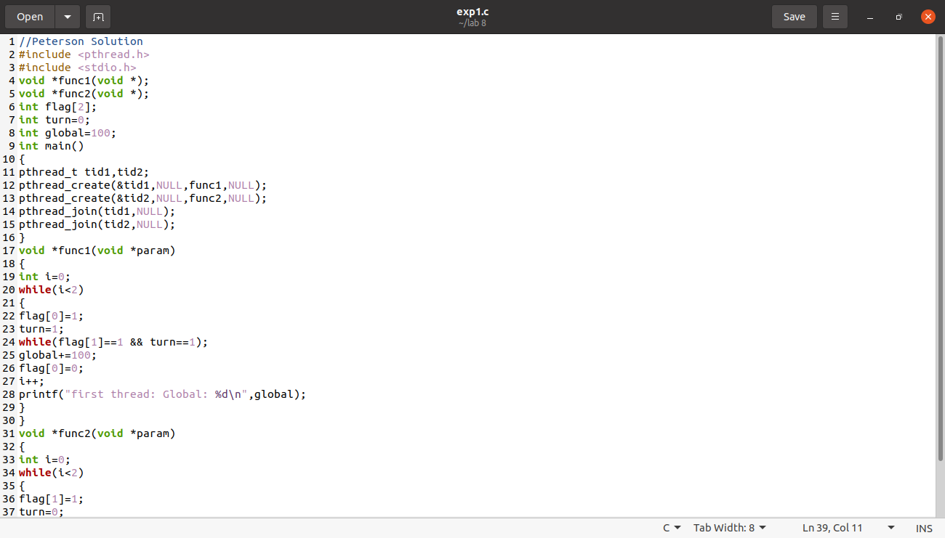

**Output:**

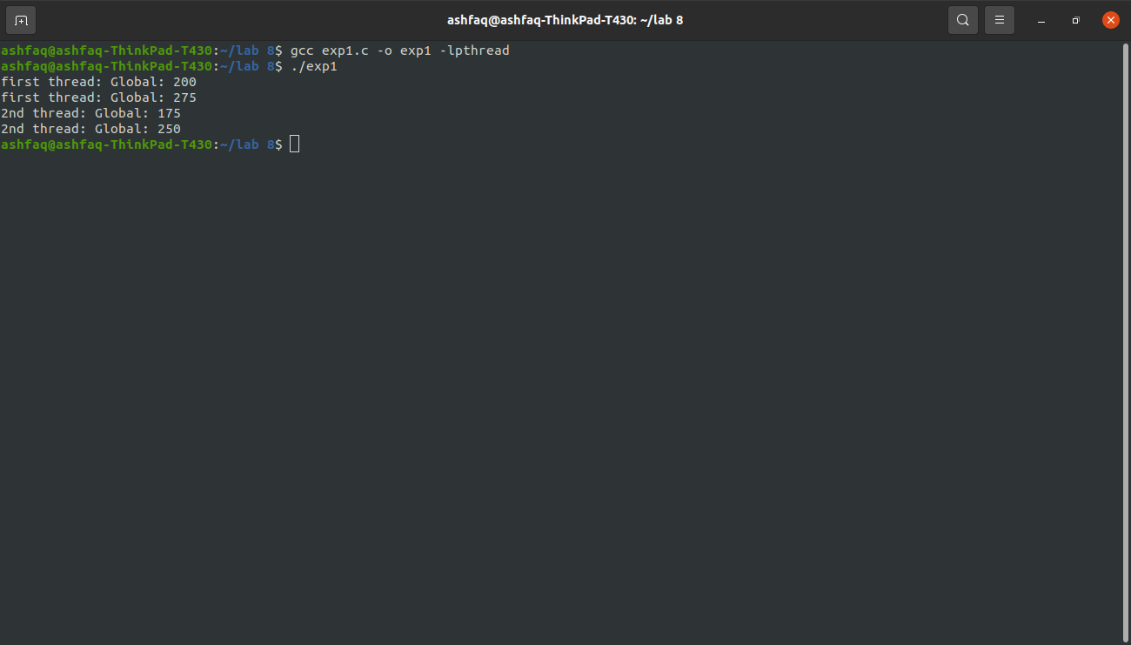

**Test and Set Instruction:**

**Code:**

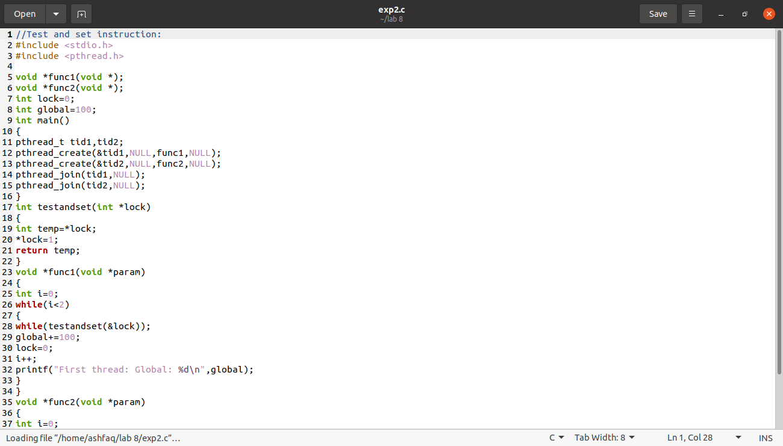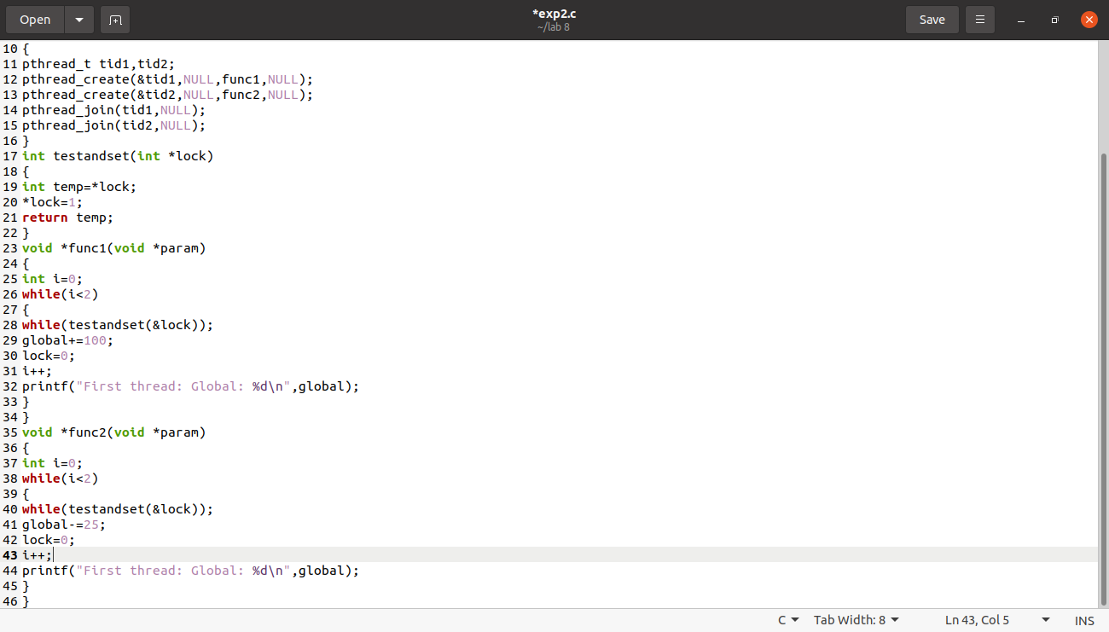

**Output :**

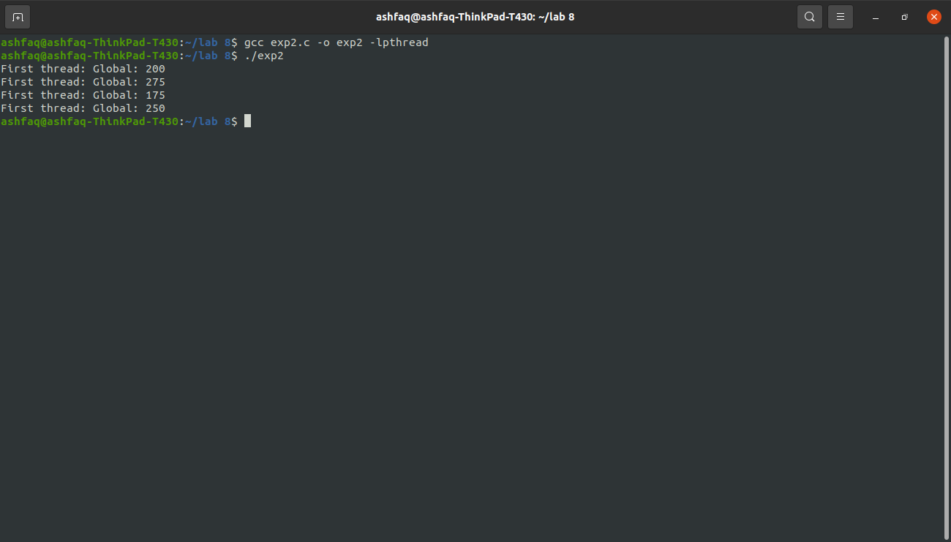

**Producer/Consumer Problem:**

**Code:**

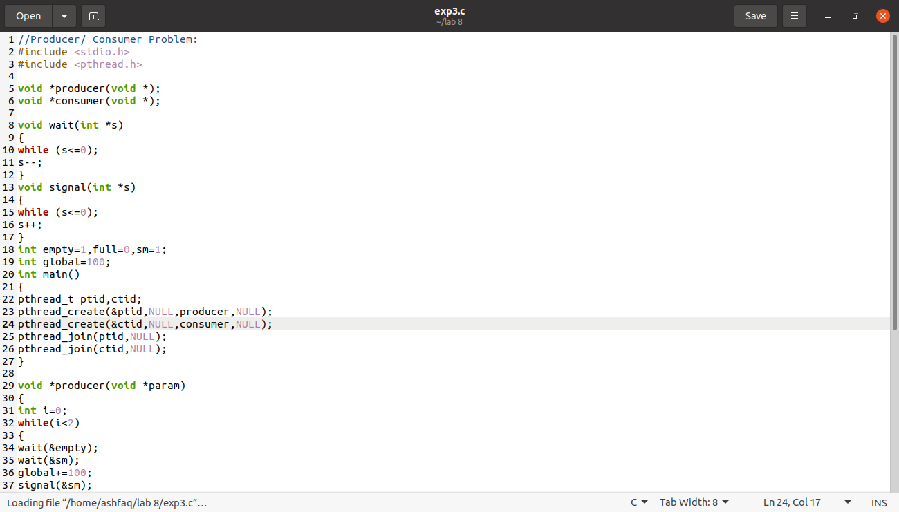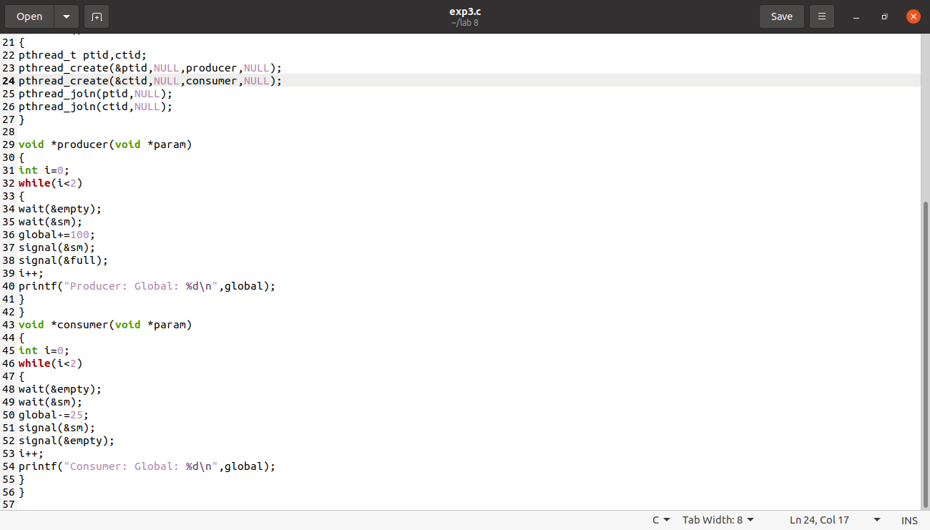

**Output:**

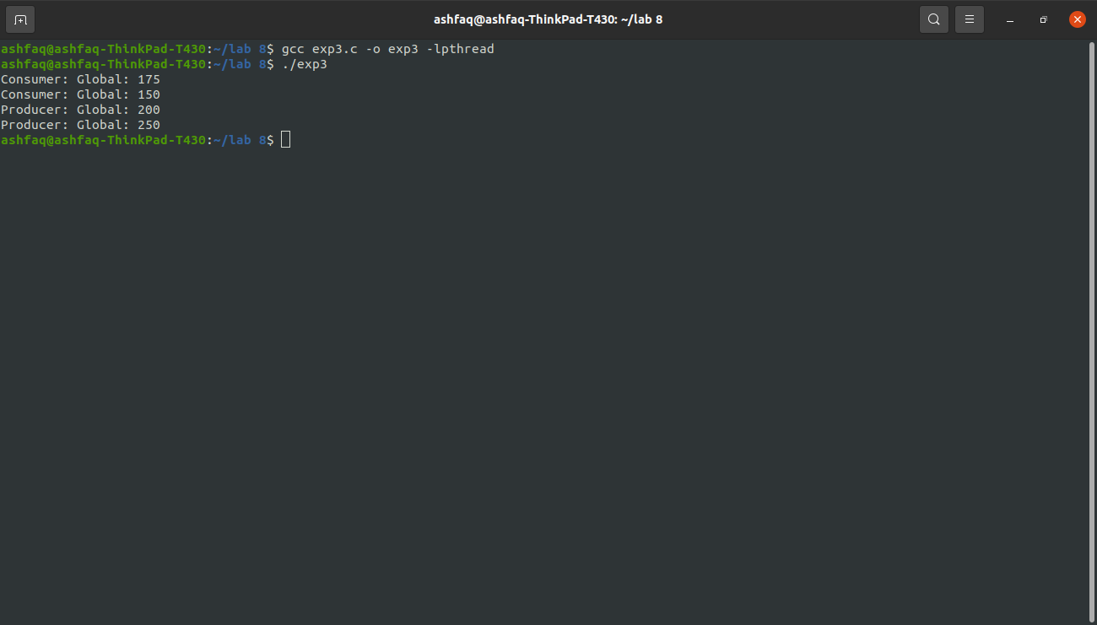

**Task # 02:**

Simulate the following Process Scheduling Algorithms:

1. First Come First Serve
2. Shortest Job First
3. Priority Scheduling
4. Shortest Time Remaining First

**First Come First Serve:**

**Code:**

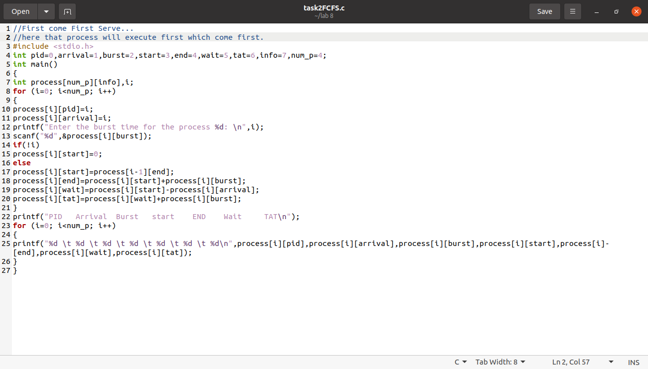

**Output:**

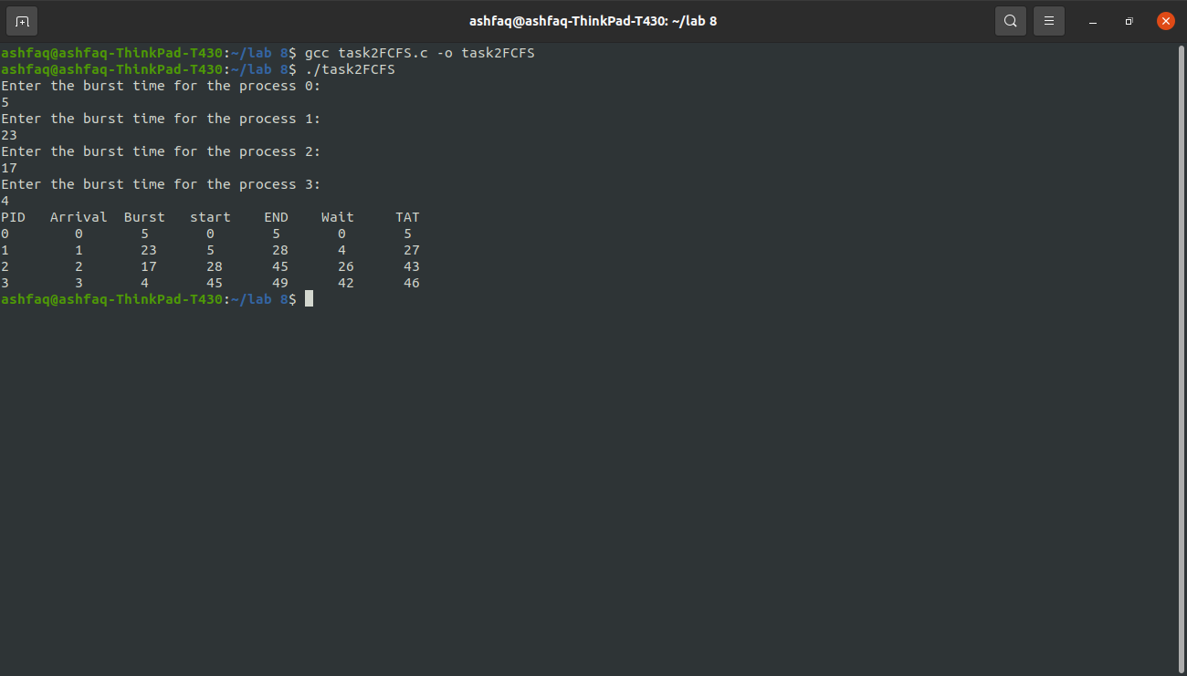

**Shortest Job First:**

**Code:**

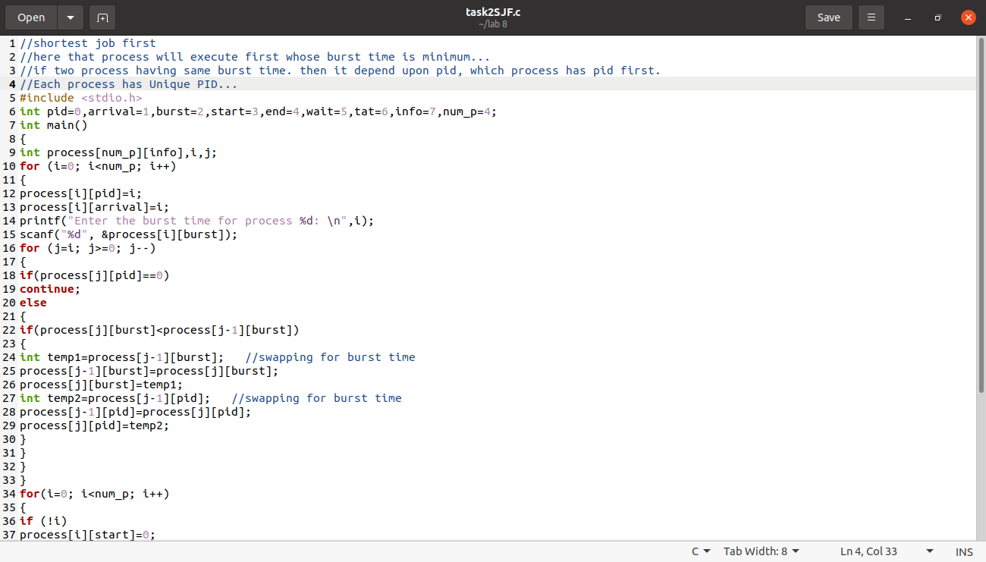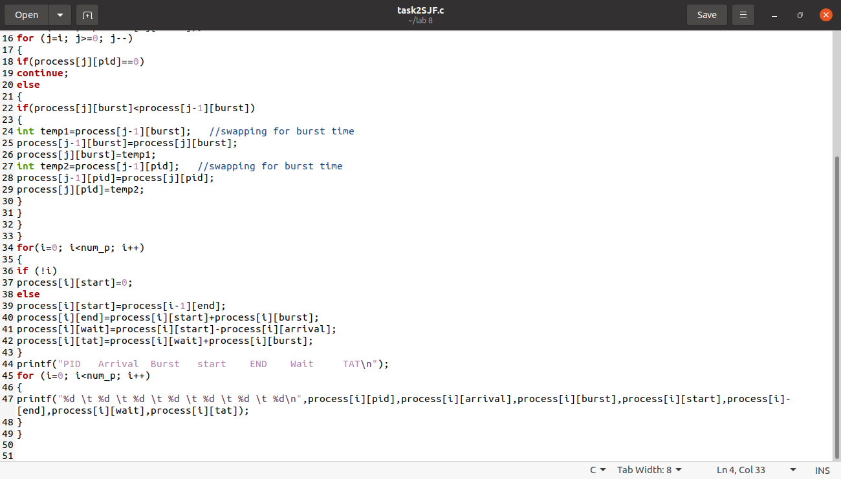

**Output:**

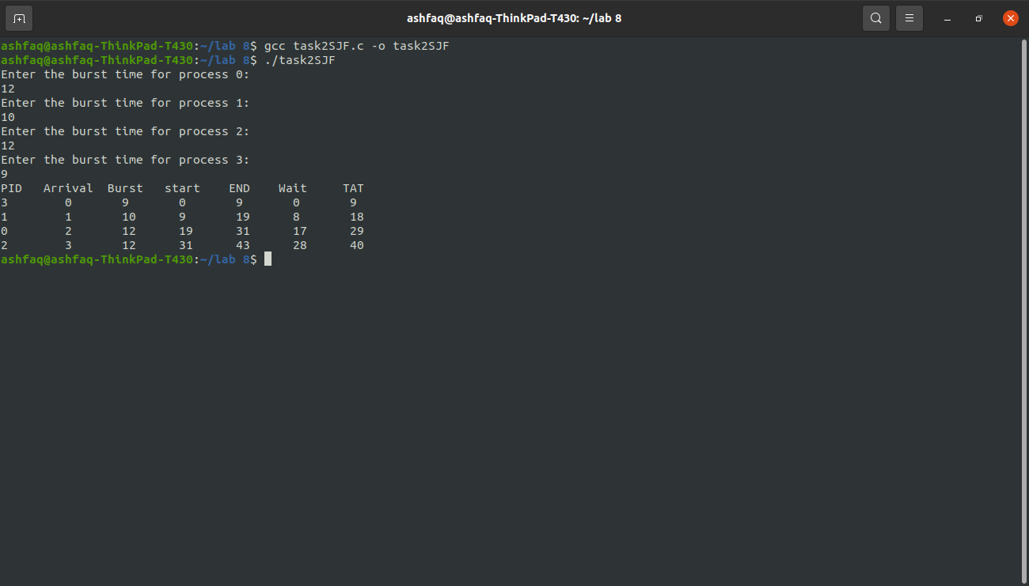

**Priority Scheduling:**

**Code:**

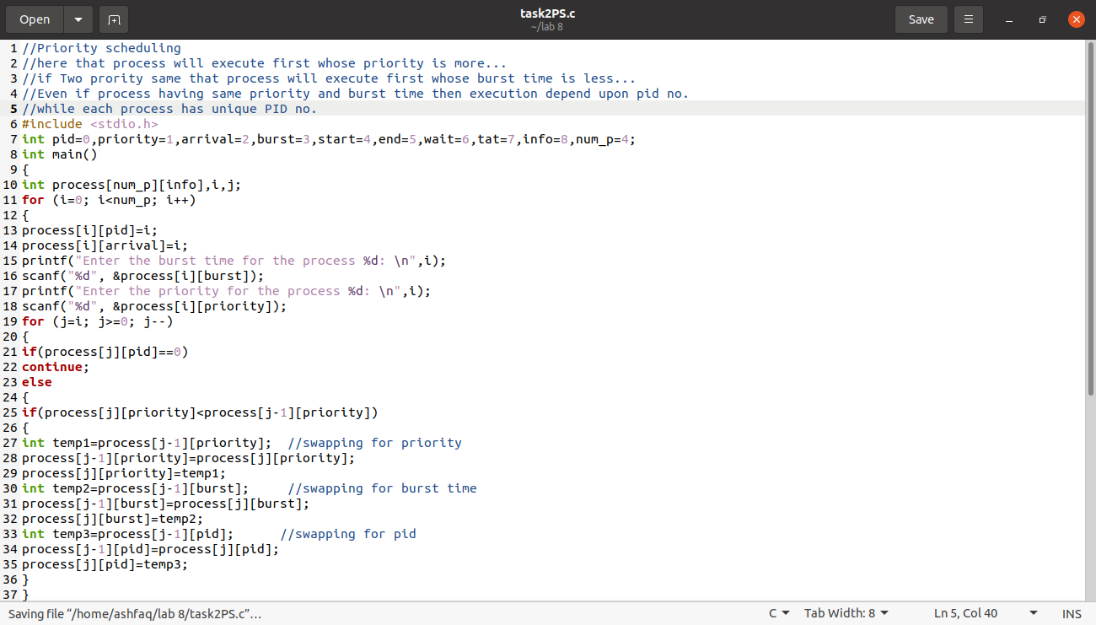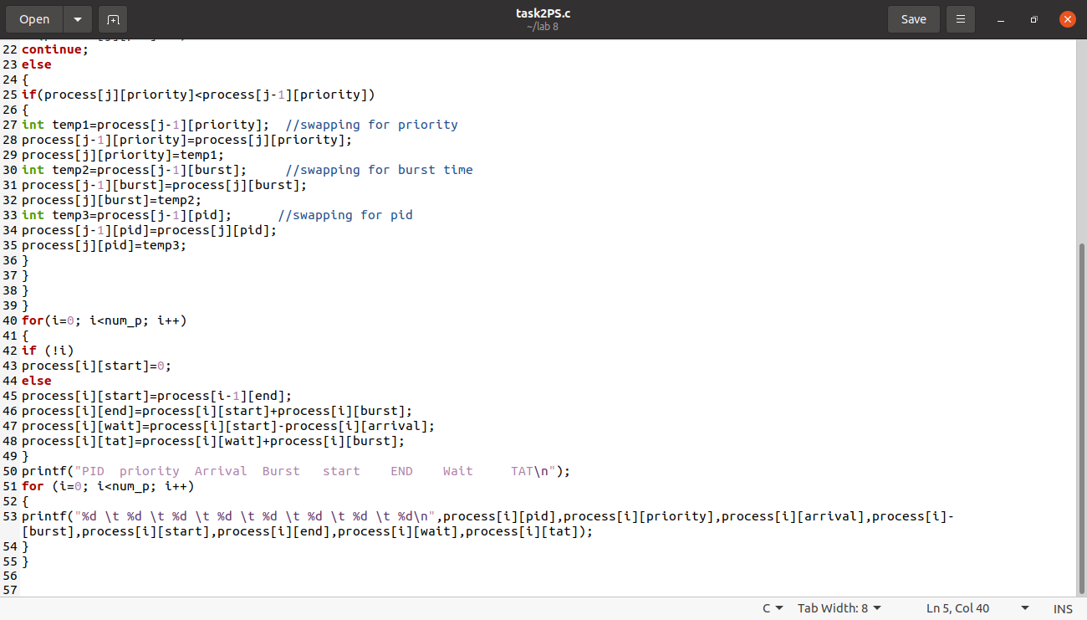

**Output:**

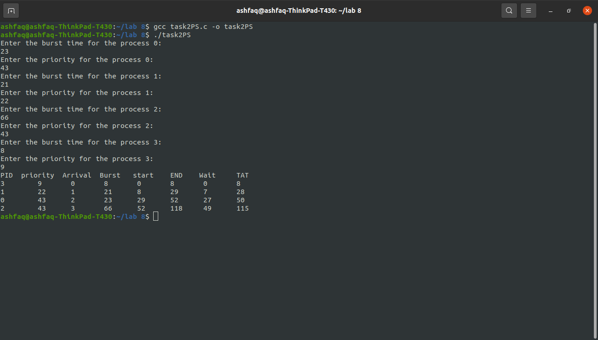

**Shortest Remaining Time First:**

**Code:**

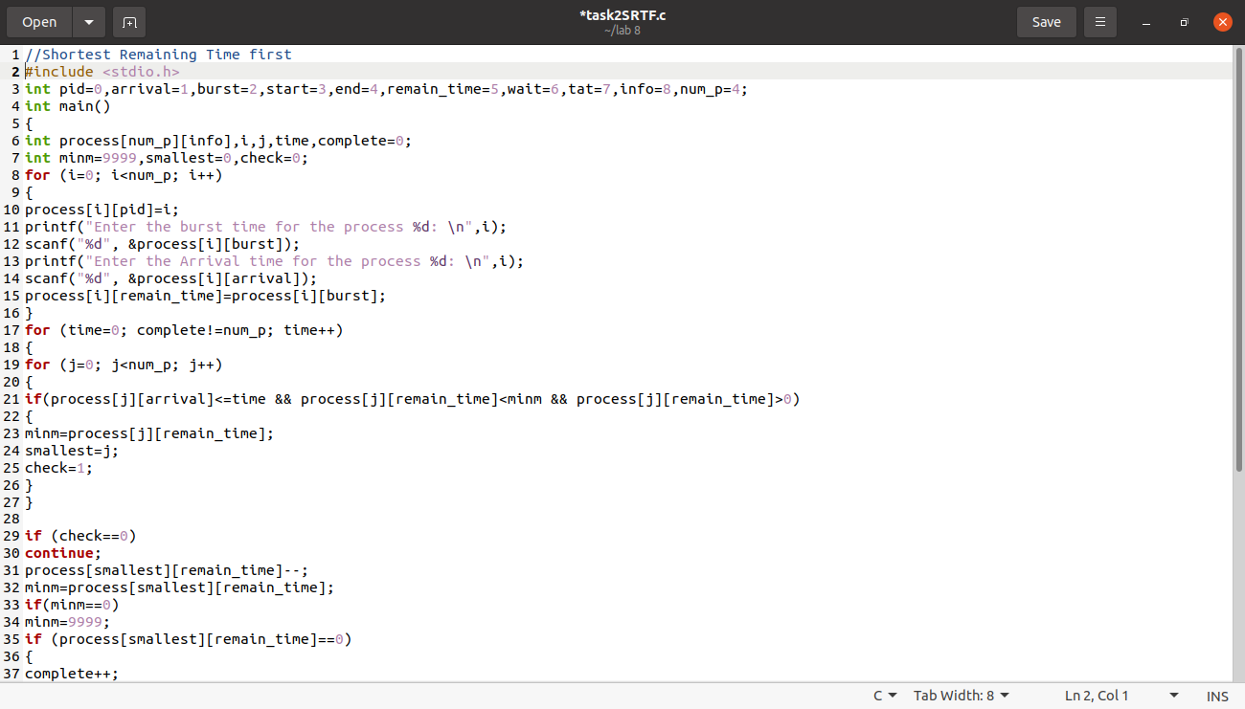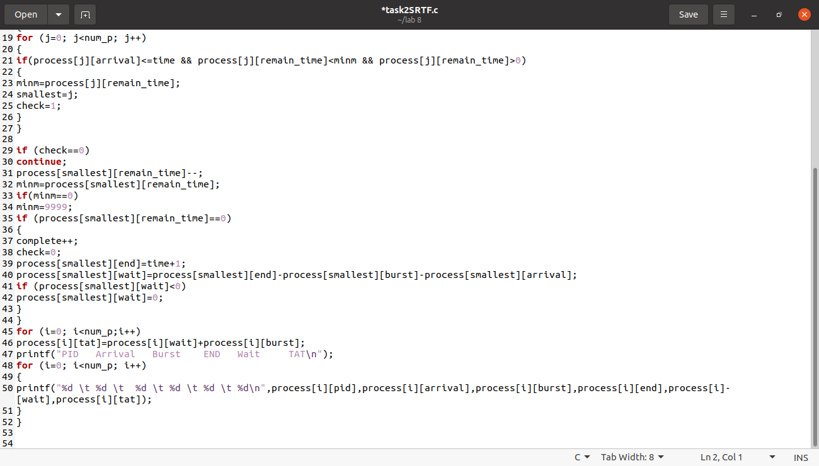

**Output:**

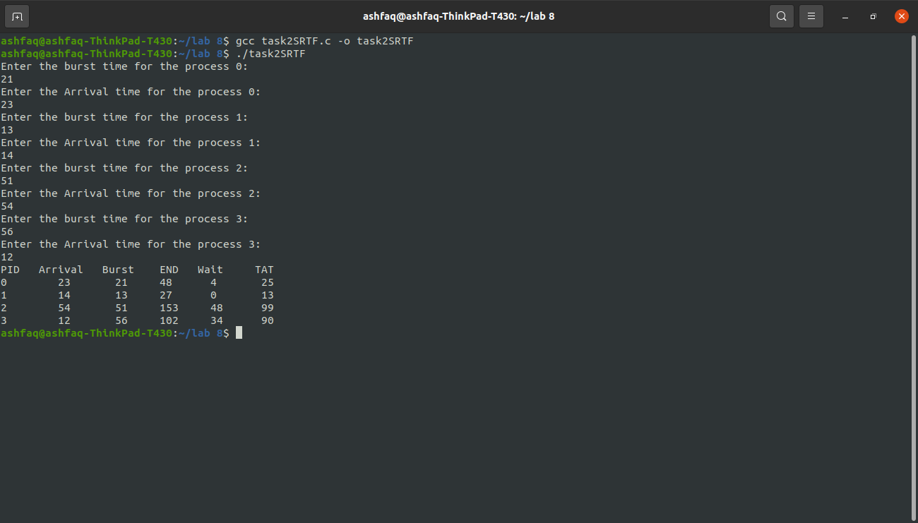

**THE END**